Lab 1- Access Your Lab Environment

Estimated completion time
- 5 minutes

Learning objectives
Upon successful completion of this lab, students will be able to:
- Access the lab Starburst Enterprise student account.
- Switch between assigned roles.

Prerequisites
- Before you begin this lab, your instructor will assign you a set of credentials and provide you with a link to access the Starburst Enterprise instance used in your class.

Activities
- Obtain your login link and credentials
- Log into the web UI
- Select the students role
- Locate the Query editor

Step 1: Obtain your login link and credentials
- Obtain login details for your class cluster. Document these on your workstation.

Step 2: Log into the SEP web UI
- Use the provided login link and credentials to access the SEP web UI.

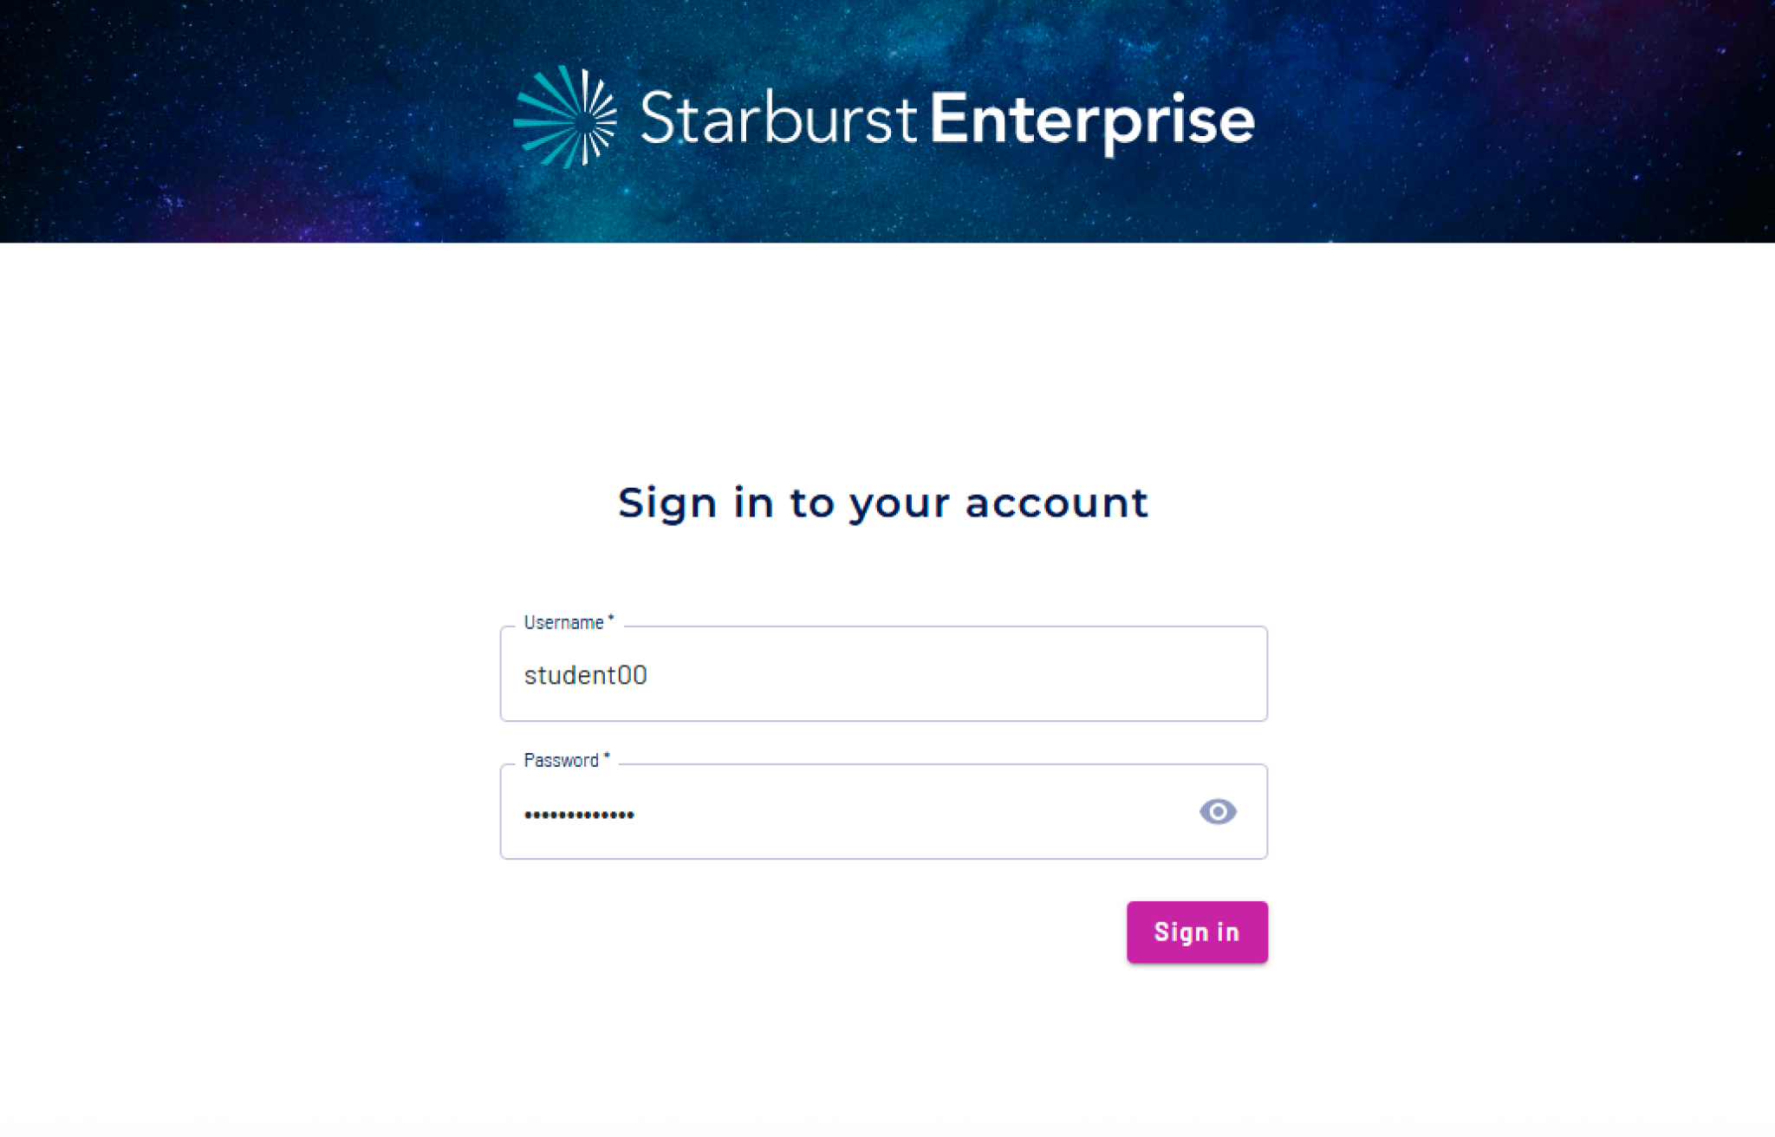

Note: The training cluster will likely not have a signed certificate. You will need to allow your browser to proceed despite the warning that it provides. For Mac users, this may be useful.

After logging in, you’ll land on the Overview page.

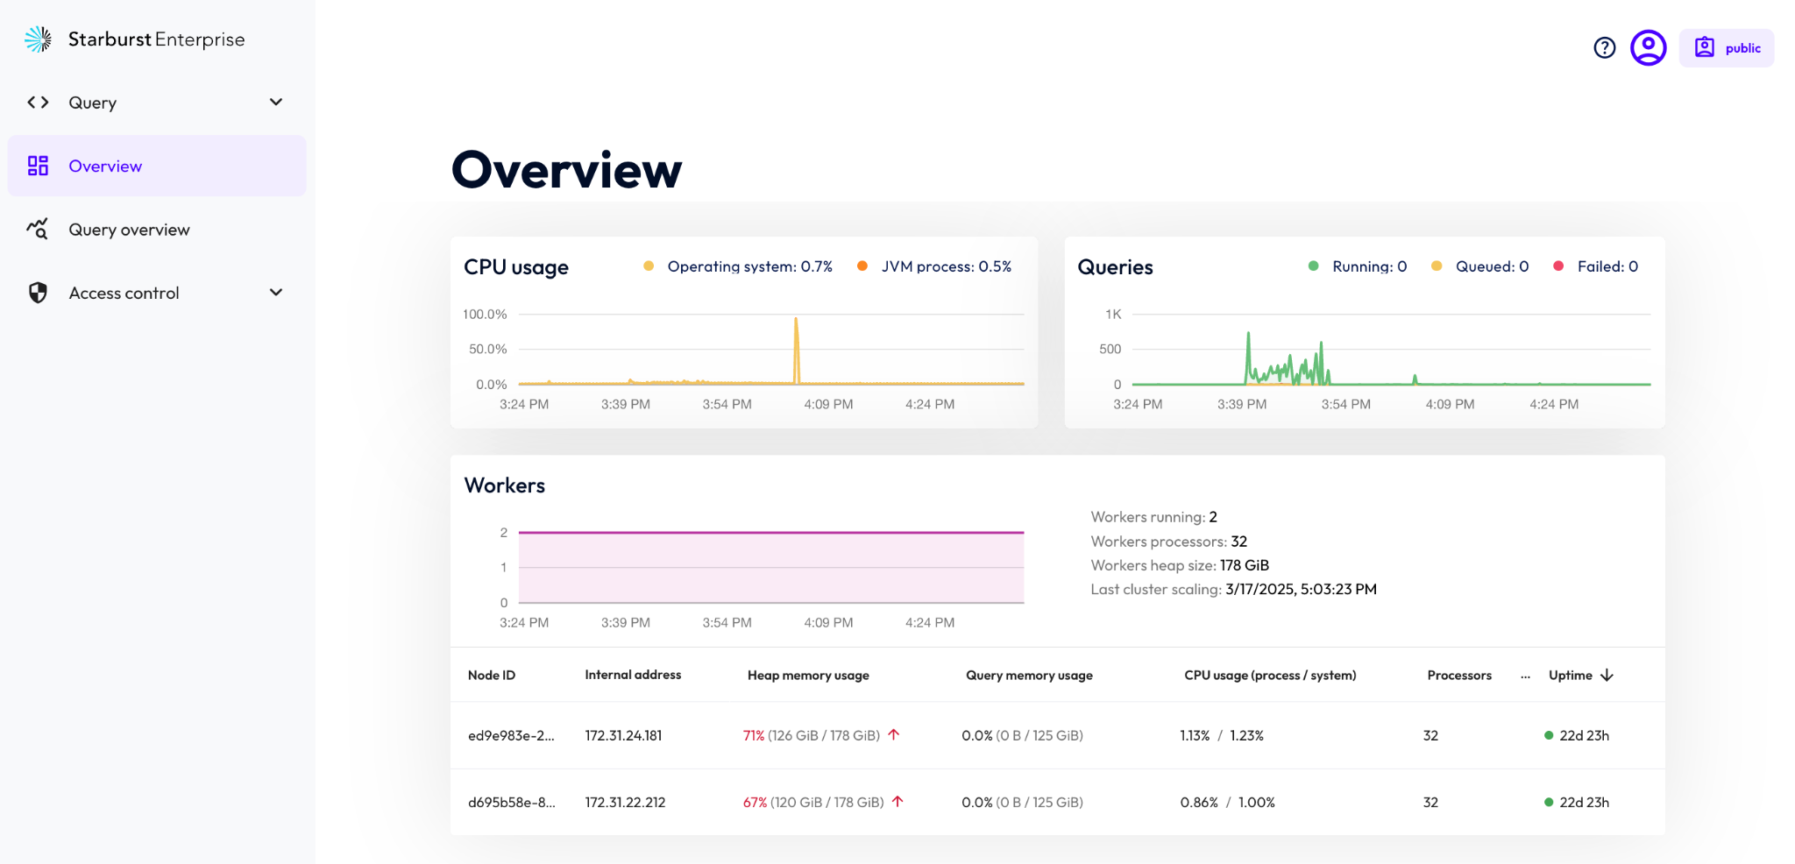

Step 3: Select the students role
- Notice your current role listed in the upper-right corner of the screen. In the image below, the role shown is public.
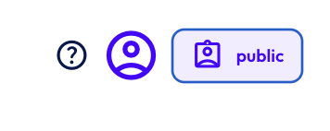

- Click on the role to open the menu, and select Switch role.

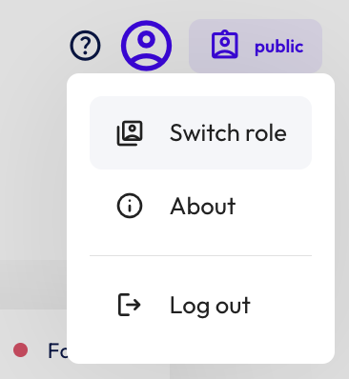

- Select the students role from the Role menu.
- Toggle the Remember selected role switch to the right.
- Finally, click on the Switch role button.

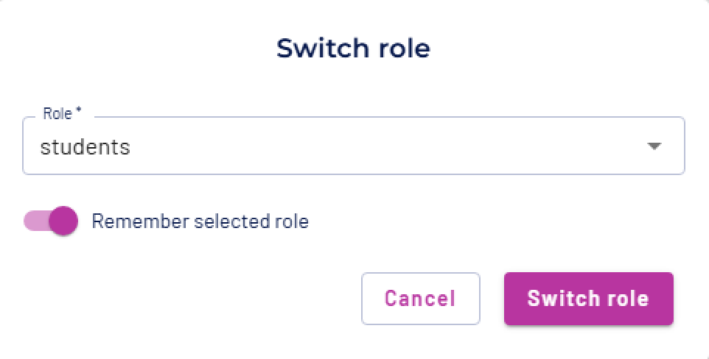

- Verify that the students role is selected.



Step 4: Navigate to the query editor
- Use the left-hand navigation menu to select Query>>Query editor.

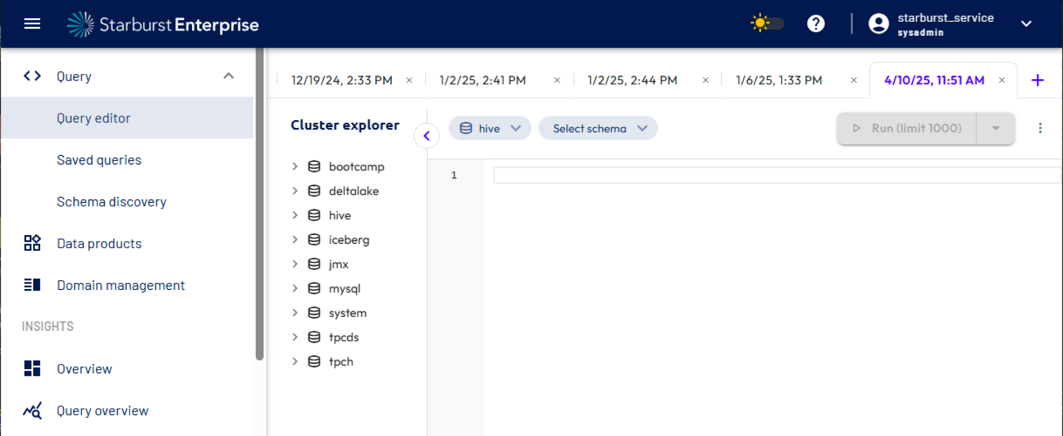

You’re ready to run some queries!

END OF LAB EXERCISE

